We are one of the most trusted providers of MS flat steel products, specializing in Pre-Painted Steel (PPGI / PPGL) / Color Coated Steel
Color-coated steel, also known as pre-painted steel, is a type of steel that has been coated with a layer of paint or a combination of paint and other protective coatings. This coating provides both aesthetic appeal and enhanced durability to the steel.
Color-coated steel finds applications in a wide range of industries and sectors. It is commonly used in roofing and cladding systems for residential, commercial, and industrial buildings. It is also utilized in the manufacturing of appliances, automotive parts, electrical panels, and various other products that require both aesthetic appeal and protection.
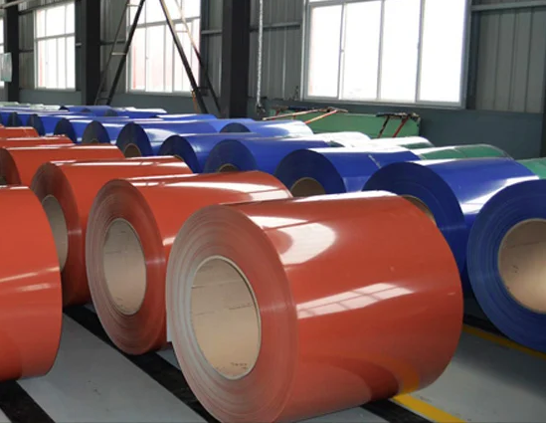
As a leading distributor for Tata Steel Ltd., one of the most reputable steel manufacturers, we are proud to offer best-in-class products that meet the highest quality standards. Our partnership with Tata Steel Ltd. exemplifies our commitment to providing our customers with top-notch steel solutions.

ALCO STEEL PROCESSORS LLP
Quality Steel. Reliable Supply. Trusted Partnership.

About Us
Alco Steel Processors LLP is a trusted supplier and processor of high-quality flat steel products. With a strong focus on reliability, quality, and customer satisfaction, we provide premium Pre-Painted Steel (PPGI / PPGL) and Color Coated Steel solutions to a wide range of industries.
Our products are sourced from leading steel manufacturers and processed to meet the highest industry standards. We are committed to delivering durable, aesthetically superior, and performance-driven steel products for modern infrastructure and industrial applications.

Our Product Range
Pre-Painted Galvanized Iron (PPGI)
High-quality galvanized steel coated with advanced paint technology, ensuring durability, corrosion resistance, and aesthetic appeal.
Pre-Painted Galvalume Steel (PPGL)
Premium galvalume steel with aluminum-zinc coating combined with paint layers for superior protection and long life.
Color Coated Steel Coils & Sheets
Available in a wide range of colors, thicknesses, and finishes to suit different industrial and architectural applications.

What is Color-Coated Steel?
Color-coated steel, also known as pre-painted steel, is produced by applying layers of protective paint and coating over galvanized or galvalume steel.
This process provides:
• Excellent corrosion resistance
• Superior surface finish
• Long-lasting durability
• Enhanced aesthetic appeal
• Low maintenance requirements
Color-coated steel is widely used in construction, manufacturing, and industrial applications where both performance and appearance are important.

Applications
Our products are widely used across various industries, including:
• Roofing & Cladding Systems
• Residential and Commercial Buildings
• Industrial Infrastructure
• Automobile Components
• Electrical Panels
• HVAC Systems
• Appliances Manufacturing
• Fabrication & Engineering Products

Our Strengths
Quality Assurance
Products sourced from reputed steel manufacturers and tested for consistency and durability.
Reliable Supply
Strong distribution network ensuring timely delivery across markets.
Customer-Centric Approach
We work closely with customers to provide solutions that match their exact requirements.
Industry Expertise
Deep understanding of steel products and their applications across sectors.
Our Commitment
At Alco Steel Processors LLP, our mission is to provide customers with high-quality steel products, dependable service, and long-term business relationships built on trust and performance.

Contact Us
ALCO STEEL PROCESSORS LLP
Sales & Customer Support
📞 Phone: [Add Phone Number]
📧 Email: [Add Email Address]
🌐 Website: [Add Website if available]

Delivering Strength, Durability, and Excellence in Steel.

